mom2mom
How to Hang Clothing
- Your hanger should be looking to the left like a question mark.
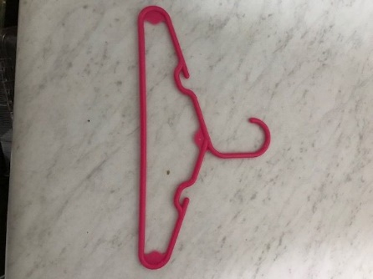
- When hanging pants on the hanger, they should be attached to the TOP of the hanger, not the bottom.
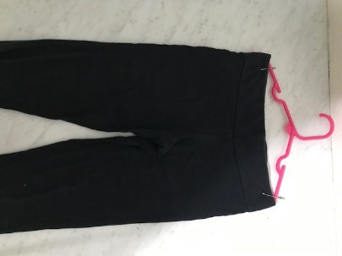
- When hanging an outfit, put the shirt on the hanger with the pants behind, NOT UNDERNEATH. Make sure that the safety pin goes through the shirt, pants and over the hanger so that it is secure.
